ES6 feature.

Object literal enhancement is used to group variables from the global scope and form them into JavaScript objects. It is the process of restructuring or putting back together

* **Shorthand for Initializing Properties:** prior to ES6, we had to manually define the names of the properties during initialization. But in ES6, if the property name is same, we don’t need to initialize it.

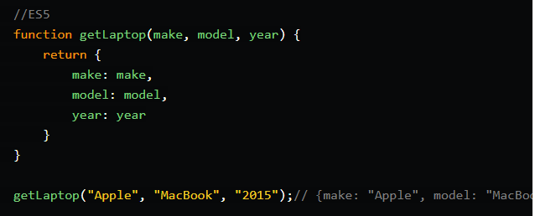

**ES6 Version:**

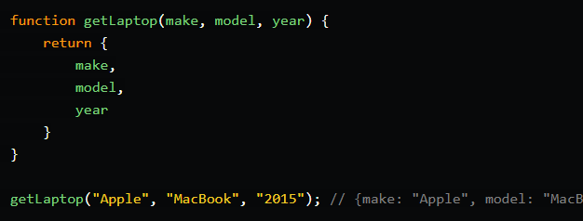

* **Shorthand for writing Methods:** prior to ES6 we had to write extra codes to write a simple function. But now we can use functions in normal ways.

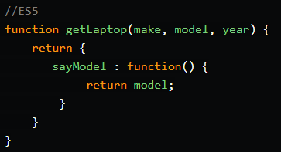

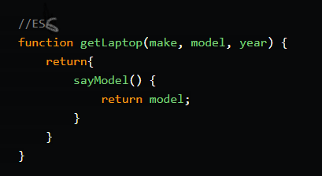

* **Computed Properties and Object Literals:** In ES6 we can compute the property and object literal. For example,

